(Approx. 832 words)

Windows 10 Helps with Vision Problems
Author: Nancy DeMarte, 2nd Vice President, Sarasota Technology Users Group, FL
September 2019 issue, STUG Monitor
www.thestug.org
education (at) thestug.org

As we age, many of us find that our vision begins to deteriorate, making it difficult to read the computer screen. Windows has a long history of aiding users with this problem, but Windows 10 has increased the number of vision assistance features and made them easier to use. This article explores the vision tools located in the Ease of Access Center on the Control Panel. Type “Control” in the Windows Search box and click Control Panel > Ease of Access Center. If you intend to visit the Ease of Access Center often, you can save time by pinning it to the Start menu or Quick Access toolbar (located above the ribbon). To do this, open the Control Panel, then right click Ease of Access Center and click your choice of locations.

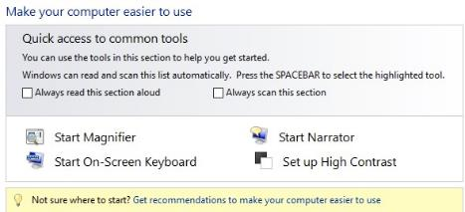
The vision section of Ease of Access has several tools. Some have so many options they can be confusing.

To help you begin, Windows 10 offers a survey which will help you know where to start, given your specific vision problems. (See the yellow box above.) Your answers will generate recommendations for which tools will give you the most help. The four most popular tools are listed above the yellow box. Below the box is a partial list of settings that can be personalized. (See below) After a setting is selected and turned on, it starts up the next time you open the Ease of Access Center and stays on until you turn it off.
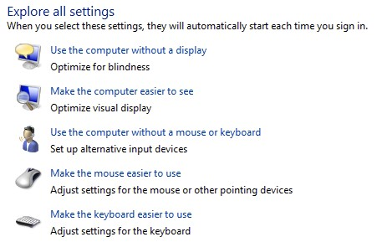

Here are brief descriptions for some of the Vision tools featured in Windows 10:

Magnifier can enlarge the contents of the whole screen, locate or dock the magnified text at the top of the screen, or create a magnifying lens which you can move with a mouse or touch to magnify specific sections of the screen. To turn on Magnifier, hold down the Windows logo key and press the + key. To turn it off, hold down the Windows logo key and press the Esc key. Magnifier has many optional settings. It is usually safer to stay with the default settings until you find you need to change one.

High Contrast makes text or graphics easier to see by emphasizing their difference. For example, a black background with white or light-colored text might be easier for some people to read. Others might prefer a white background with black text. To turn high contrast on or off, hold down the Shift and Alt keys on the left side of the keyboard and press the Print Screen key (PrtScr) on the top row of the keyboard.

Narrator is a screen reader. After you choose a male or female voice, Narrator reads aloud everything on the screen and can describe the content of videos (Audio Description).

Narrator is easy to turn on and off from Ease of Access Center or by typing Narrator in the Search box. Adjustments can be made to the reading speed. You will need speakers to use this tool. Some recent changes made to Narrator are explained in the box below:
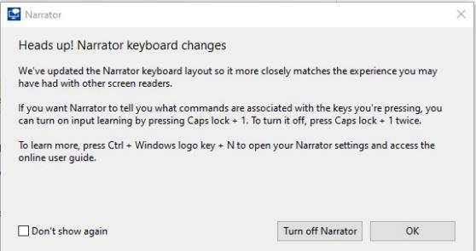

On-Screen Keyboard is a keyboard which appears on the screen with a black background and white characters. This keyboard option may be easier for some users to see. It can be used with a mouse or touch if you use a touch screen computer.

Display includes tools to make your screen easier to read. Use the slider to change the text size or brightness of the display. A few other settings are shown below:

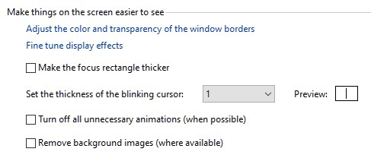

Cursor and Pointer lets you choose the size and color of the mouse pointer and cursor. This is a good option for those who have trouble finding the pointer on the screen. More settings for a mouse pointer can be found in the Control Panel in ‘Mouse’.
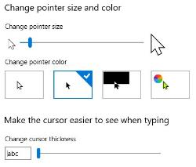

Color Filters are options for those with color blindness. Choose between grayscale or various color groupings until you find one that makes it easier to see photos or colored graphics.

Speech Recognition: If you have your PC connected to the Internet and have turned on ‘speech recognition’ in the Control Panel, your computer will type your words as you speak them. You must also turn on the computer’s microphone. To do this, type ‘microphone’ in the Search box. As of now, speech recognition includes six languages.

Cortana: Microsoft’s digital assistant, Cortana, is an easy-to-use shortcut to many types of tasks, such as opening an app, sending an email, and answering questions. Just turn on Cortana by typing her name in the Search box and talk to her.
Not all the tools described here are found in Ease of Access. Type a tool’s name in the Windows Search box to find it. Most of the accessibility tools have a “Get Help” link to click if you need assistance. If you need even more help, talk to Cortana.

